Project Design Phase-II Technology Stack (Architecture & Stack)

|  |  |
| --- | --- |
| Date | 03 October 2022 |
| Team ID | PNT2022TMID17544 |
| Project Name | Project – Plasma Donor Application |
| Maximum Marks | 4 Marks |

Technical Architecture:

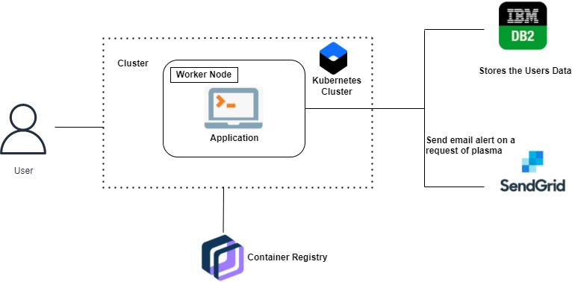

Table-1 : Components & Technologies:

|  |  |  |  |
| --- | --- | --- | --- |
| **S.**  **No** | **Component** | **Description** | **Technology** |
| 1 | User Interface | User interacts with user friendly web interface that directs them to functions of the application such as registration, booking  appointments etc. | HTML & CSS,  JavaScript, React JS |
| 2 | Application Logic-1 | Web application framework upon  which application is designed | Flask (Python) |
| 3 | Application Logic-2 | Storing details of users (donors,  doctors, patients etc.) | IBM DB2 |
| 4 | Application Logic-3 | Email alert is sent in request of  plasma | SendGrid |
| 5 | Database | Data Type, Configurations etc. | MySQL, NoSQL, etc. |
| 6 | Cloud Database | Database Service on Cloud | IBM DB2, IBM Cloudant  etc. |
| 7 | File Storage | File storage requirements | IBM Block Storage or Other Storage Service or  Local Filesystem |

|  |  |  |  |
| --- | --- | --- | --- |
| 8 | External API-1 | Platform to build containerised  applications | Docker. |
| 9 | External API-2 | To store, manage and deploy  container images | IBM Container Registry |
| 10 | Infrastructure (Server /  Cloud) | Application Deployment on Local  System / Cloud | Local, Cloud Foundry,  Kubernetes |

Table-2: Application Characteristics:

|  |  |  |  |
| --- | --- | --- | --- |
| **S.**  **No** | **Characteristics** | **Description** | **Technology** |
| 1 | Open-Source Frameworks | Flask (Python) is an open source framework used to develop web applications, Kubernetes is an open-source container orchestration system for automating software deployment, scaling, and  management | Python – flask, Kubernetes |
| 2 | Security Implementations | Kubernetes cluster and IBM container registry are used for  encryption of data. | IBM Container Registry, Kubernetes |
| 3 | Scalable Architecture | Kubernetes is used for deployment, scaling and  management | Kubernetes |
| 4 | Availability | All time availability is provided by  cluster | Kubernetes |
| 5 | Performance | Docker improves performance of  application | Docker |